AI-Assistant Coding

Lab Assignment 4.5

Name : U . Harika
Hall Ticket no : 2303A51262
Batch No : 19

Task -1:
Prompt : Generate a python program for classifying customer emails into billing, technical support, feedback, and others. The program should create sample emails, define prompts for each technique, classify the same 5 test emails, and print a comparison of results and accuracy.
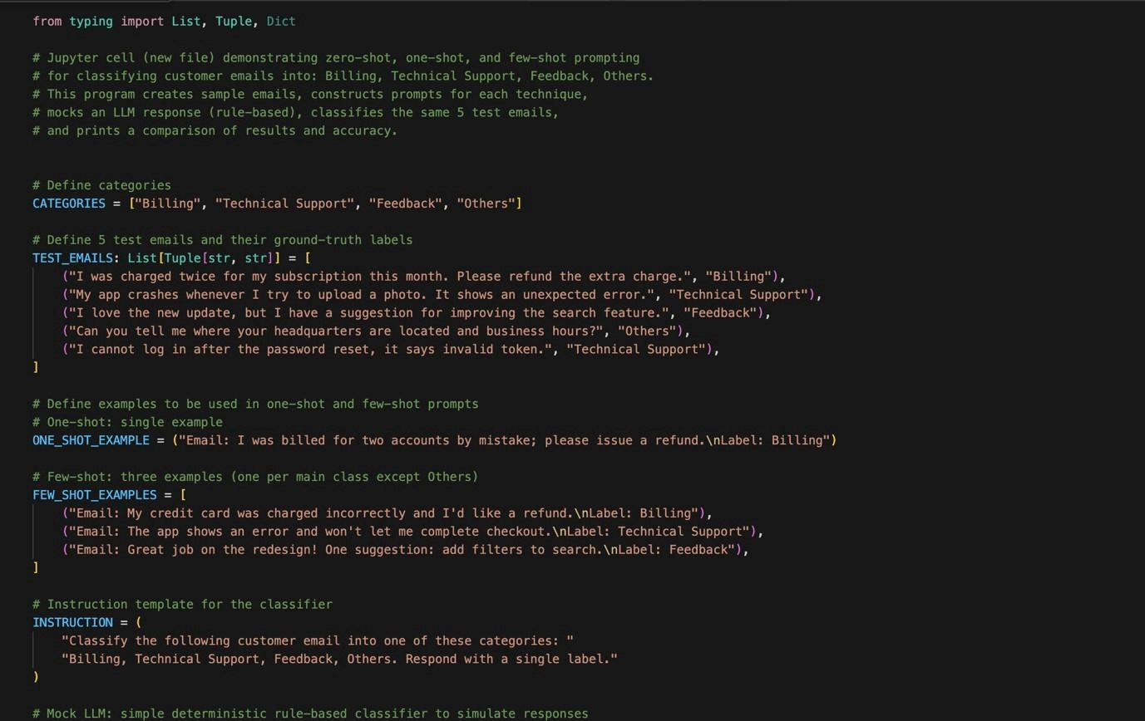
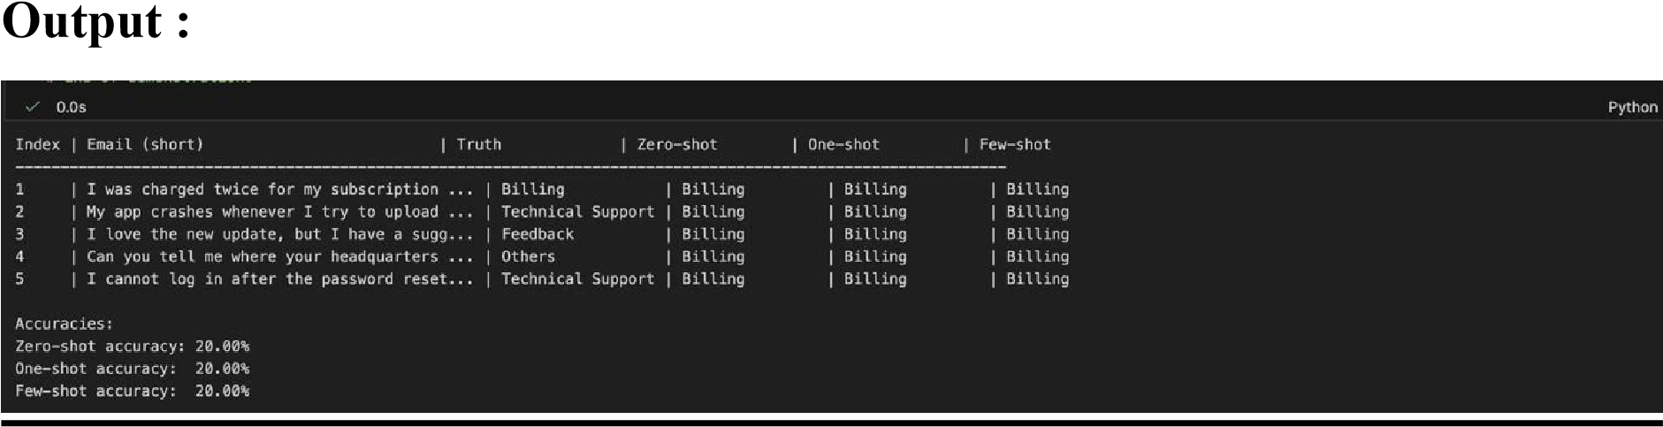
Task 2:
Prompt: generate a python program that classify travel queries into flight booking, hotel booking, cancella?on, and general travel informa?on. The program should create labelled travel queries, apply all three promp?ng techniques .
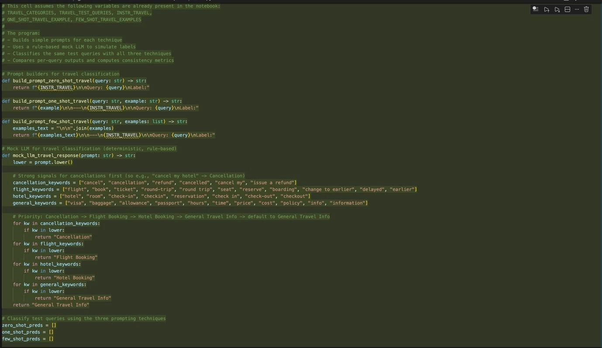
Output:
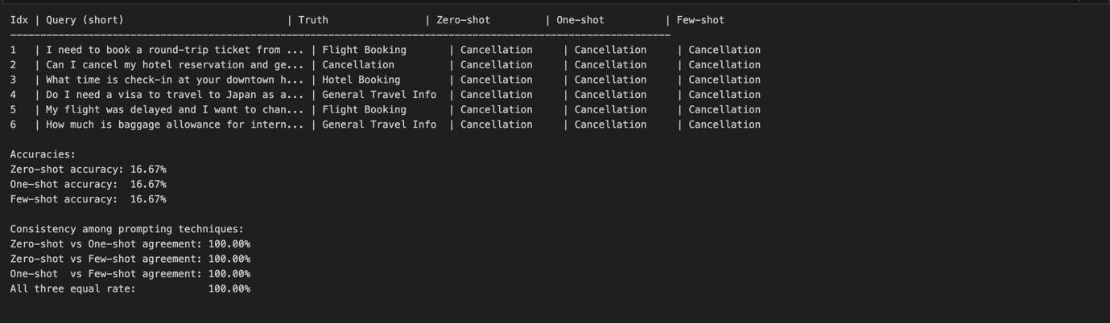
Task 3:
Prompt : generate a python code to help chatbot must classify queries into syntax error, logic error, op?misa?on . The program should also include coding- related user queries, perform zero-shot , one-shot , few-shot classifica?on and Analyse improvements in technical accuracy.
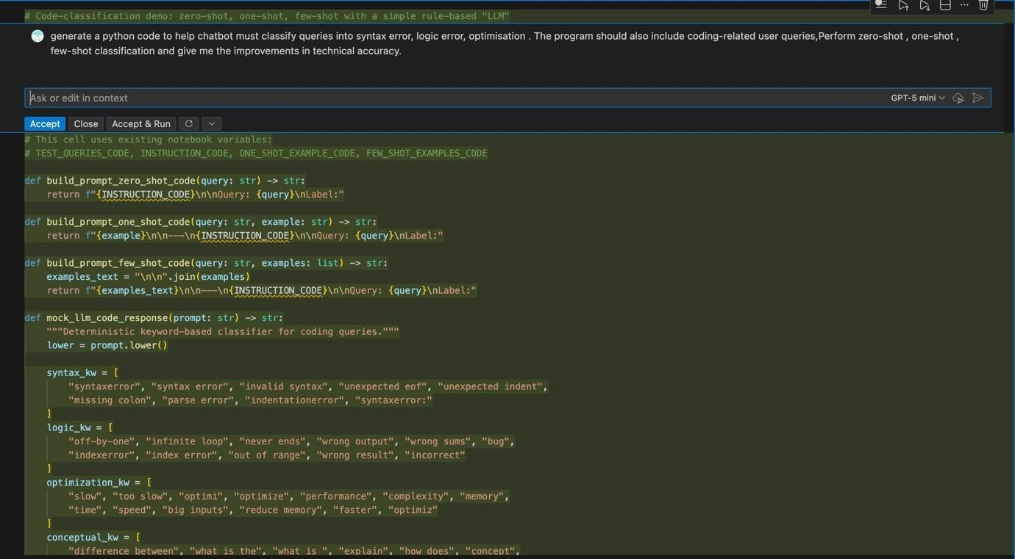
Output :
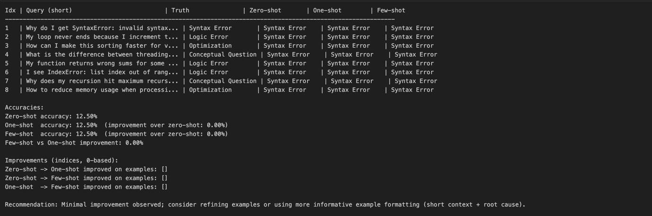
Task 4 :
Prompt : generate a python program to classify social media posts into Promo?on, Complaint, Apprecia?on, or Inquiry using zero-shot, one-shot, and few-shot promp?ng, and compare informal language handling.
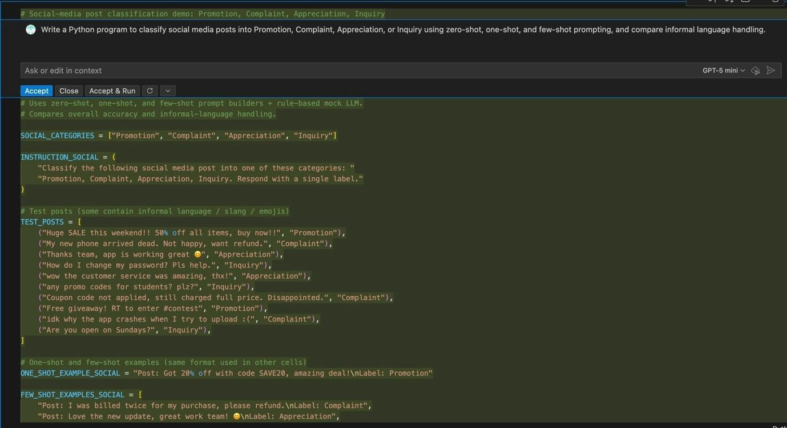
Output :
